**PROJECT REPORT**

**ON**

**APPLICATION OF FFT IN DETECTION OF LOW IMPEDANCE FAULTS IN POWER SYSTEM NETWORK FOR DIFFERENT VALUES OF GROUND RESISTANCE**

Project Report submitted for partial fulfilment of the requirements for the

Degree of B. Tech.

In

Electrical Engineering

**Submitted by**

Name of the Student University Roll No.

Sayan Das 430317010101

Ritesh Majumdar 430317010103

Arindam Pal 430317010104

Nilay Dey 430317010105

Mirtunjay Kumar 430317010106

Under the Guidance of

Prof. Dr. Nabamita Banerjee Roy

Associate Professor

Department of Electrical Engineering

Narula Institute of Technology

An Autonomous Institute under Maulana Abul Kalam Azad University (Formerly West Bengal University Technology) 81, Nilgunj Road, Agarpara, Kolkata – 700 109 West Bengal, India

2017-2021

**RECOMMENDATION**

I hereby recommend that the project titled ***“Application of Fft in Detection of Low Impedance Faults in Power System Network for Different Values of Ground Resistance***

***”***. Submitted by Arindam Pal, Sayan Das, Ritesh Majumdar, Nilay Dey and Mirutnjay Kumar.

Accepted in partial fulfilment of the requirement for the Degree of B. Tech. in Electrical Engineering from the Department of Electrical Engineering, Narula Institute of Technology, and an autonomous Institute under Maulana Abul Kalam Azad University of Technology (Formerly West Bengal University Technology).

Place:

Date:

______________________

(Project supervisor)

**CERTIFICATE OF APPROVAL**

The seminar report entitled ***“Application of FFT in Detection of Low Impedance Faults in Power System Network for Different Values of Ground Resistance”***. Prepared by Arindam Pal, Sayan Das, Ritesh Majumdar, Nilay Dey and Mirutnjay Kumar, is hereby approved and certified as a creditable study in technology subjects performed in a way sufficient for acceptance for partial fulfilment of the degree for which it is submitted. It is to be understood that by this approval, the undersigned do not necessarily endorse or approve any statement made, opinion expressed or conclusion drawn therein, but approve the seminar only for the purpose for which it is submitted. The content of this project report, in full or in parts, has not been submitted to any other institution or university for the award of any Degree or Diploma.

Place:

Date:

________________

(Project supervisor)

________________

(External examiner)

_______________

(H.O.D)

**ACKNOWLEDGEMENT**

I/we would like to extend my/our sincere and profound gratitude to my/our Potential Supervisor, Dr. Nabamita Banerjee Roy, Associate professor Electrical Engineering Department of Narula Institute of Technology, Kolkata for her experienced guidance, perseverance and hospitality.

In this connection, I/we would also like to thank those people, directly or indirectly, attached to the department without whose help and support, I/we could not have done it.

Though utmost care has been taken to make the report error free, a few inadvertent errors have crept in which is regretted. Any technical suggestion regarding this report will be highly appreciated.

**TABLE OF CONTENTS**

Contents

Chapter 1. INTRODUCTION 9

Chapter 2: Power System Faults 11

2.1 Types of Faults: 12

2.1.1 Open Circuit Faults: 12

2.2.2 Short Circuit Faults 13

2.2.3 Symmetrical and Unsymmetrical Faults 14

2.2.3.1 Symmetrical Faults 14

2.2.3.2 Unsymmetrical Faults 15

Chapter 3: Fast Fourier Transform (FFT) 17

3.1 Signals 18

3.2 Periodic Signal: 19

3.3 Time‐Frequency Analysis: 19

3.4 Fourier Transform: 20

3.4.1 Fourier Representation for Four Types of Signals: 20

3.5 Periodic Sequence: 21

3.6 Discrete Fourier series (DFS): 21

3.7 Finite Length Sequence 21

3.8 Relationship between Finite Length Sequence and Periodic Sequence 22

3.9 Discrete Fourier Transform (DFT): 22

3.9.1 DFT Example 23

3.10Fast Fourier Transform (FFT) 24

Chapter 4: Simulation of Low Impedance Faults in a Power System Network 25

4.1 Simulation of Power system network: 26

4.2. Simulation of Faults: 27

Chapter 5: Application of FFT (Fast Fourier Transform) in Fault Classification 31

5.1. Method of analysis: 32

5.2. Plot of signal Features: 36

5.3. Plot of signal features of three phases for 5-ohm ground resistance: 39

4.2 Discussion: 43

Chapter 5: Conclusion and future scope of work 44

REFERENCE 46

**TABLE OF FIGURES**

Figure 4.1 Single Line diagram of 400 kV, 50 Hz, 3-phase power system network. 26

Figure 4.2 3 Phase Voltage Waveform during AG type fault occurring at 100 km from sending end B1 with ground resistance 5 ohm 27

Figure 4.3 3 Phase Voltage Waveform during CG type fault occurring at 100 km from sending end B1 with ground resistance 5 ohm 28

Figure 4.4 3 Phase Voltage Waveform during BG type fault occurring at 100 km from sending end B1 with ground resistance 5 ohm 28

Figure 4.5 3 Phase Voltage Waveform during ABG type fault occurring at 100 km from sending end B1 with ground resistance 5 ohm 29

Figure 4.6 3 Phase Voltage Waveform during BCG type fault occurring at 100 km from sending end B1 with ground resistance 5 ohm 29

Figure 4.7 3 Phase Voltage Waveform during CAG type fault occurring at 100 km from sending end B1 with ground resistance 5 ohm 30

Figure 4.8 3 Phase Voltage Waveform during ABCG type fault occurring at 100 km from sending end B1 with ground resistance 5 ohm 30

Figure 5.1 Frequency spectrum of the voltage signal of phase A during AG type of fault occurring at 100 km from the sending end of the power system 32

Figure 5.2 Frequency spectrum of the voltage signal of phase B during BG type of fault occurring at 100 km from the sending end of the power system 33

Figure 5.3 Frequency spectrum of the voltage signal of phase C during CG type of fault occurring at 100 km from the sending end of the power system 33

Figure 5.4 Frequency spectrum of the voltage signal of phase A during ABG type of fault occurring at 100 km from the sending end of the power system 34

Figure 5.5 Frequency spectrum of the voltage signal of phase B during BCG type of fault occurring at 100 km from the sending end of the power system 34

Figure 5.6 Frequency spectrum of the voltage signal of phase C during CAG type of fault occurring at 100 km from the sending end of the power system 35

Figure 5.7 Frequency spectrum of the voltage signal of phase A during ABCG type of fault occurring at 100 km from the sending end of the power system 35

Figure 5.8 Plots of magnitudes of features obtained from FFT with respect to fault Location in case of BG fault (phase B) 36

Figure 5.9 Plots of magnitudes of features obtained from FFT with respect to fault location in case of AG fault (phase A) 36

Figure 5.10 Plots of magnitudes of features obtained from FFT with respect to fault location in case of CG fault (phase C) 37

Figure 5.11 Plots of magnitudes of features obtained from FFT with respect to fault location in case of ABG fault (phase B) 37

Figure 5.12 Plots of magnitudes of features often from FFT with respect to fault location in case of ABCG fault (phase A) 38

Figure 5.13 Plots of magnitudes of features obtained from FFT with respect to fault location in case of BCG fault (phase A) 38

Figure 5.14 Plots of magnitudes of features obtained from FFT with respect to fault location in case of AG type of fault for the three phases with ground resistance 5 ohm 39

Figure 5.15 Plots of magnitudes of features obtained from FFT with respect to fault location in case of BG type of fault for the three phases with ground resistance 5 ohm 39

Figure 5.16 Plots of magnitudes of features obtained from FFT with respect to fault location in case of CG type of fault for the three phases with ground resistance 5 ohm 40

Figure 5.17 Plots of magnitudes of features obtained from FFT with respect to fault location in case of ABG type of fault for the three phases with ground resistance 5 ohm 40

Figure 5.18 Plots of magnitudes of features obtained from FFT with respect to fault location in case of CAG type of fault for the three phases with ground resistance 5 ohm 41

Figure 5.19 Plots of magnitudes of features obtained from FFT with respect to fault location in case of BCG type of fault for the three phases with ground resistance 5 ohm 41

Figure 5.20 Plots of magnitudes of features obtained from FFT with respect to fault location in case of ABCG type of fault for the three phases with ground resistance 5 ohm 42

# 

# Chapter 1

# INTRODUCTION

Fast detection of faults allows the relays to isolate the faulty part from the rest of the power system in order to protect the assets of the faulty part and to continue power supply to the healthy part. In addition, the accurate classification of faults provides necessary information regarding fault location that expedites the required repair works. Consequently, fast and reliable fault detection and classification have become an essential operational requirement of modern electricity grids.

The electrical power system is very large, complex and spread over a large geographical area. The electrical power system consists of a generator, transformer, transmission lines and load. A fault in a circuit is the disturbance or failure, which interfere the normal system operation.

Fault usually occurs in a power system due to insulation failure, flashover, physical damage such as wire blowing together in the wind, an animal coming in contact with the wire. Fault usually causes the flow of excessive current, abnormal voltages, induce overvoltage on neighbouring equipment and cause hazards to human, animals, etc. Fault analysis is generally needed to select the size of circuit breaker fuse and characteristics, setting of the relay. Fuse, circuit breaker, relays, lighting power protection device are some of the fault limiting devices.

The rest of the project report is organised as follows. Chapter 2 discusses about Power System Faults. Chapter 3 describes about Fast Fourier Transform (FFT). The simulation of power system faults is explained in Chapter 4. Application of FFT in extraction of features from the voltage signals and the results are in Chapter 5. Conclusion and Future Scope of Work are given in Chapter 6.

# 

# Chapter 2

# Power System Faults

The fault in the power system is defined as the defect in the power system due to which the current is distracted from the intended path. The fault creates the abnormal condition which reduces the insulation strength between the conductors. The reduction in insulation causes excessive damage to the system.

## 2.1 Types of Faults:

Electrical faults in three-phase power system mainly classified into two types, namely open and short circuit faults. Further, these faults can be symmetrical or unsymmetrical faults. Let us discuss these faults in detail.

## 2.1.1 Open Circuit Faults:

These faults occur due to the failure of one or more conductors. The figure below illustrates the open circuit faults for single, two and three phases (or conductors) open condition.

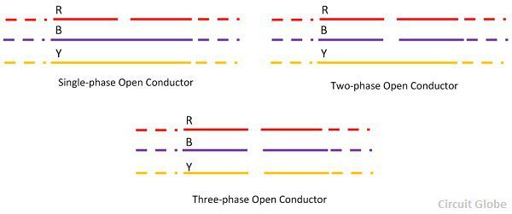

The most common causes of these faults include joint failures of cables and overhead lines, and failure of one or more phase of circuit breaker and also due to melting of a fuse or conductor in one or more phases. Open circuit faults are also called as series faults. These are unsymmetrical or unbalanced type of faults except three phase open fault.

Consider that a transmission line is working with a balanced load before the occurrence of open circuit fault. If one of the phase gets melted, the actual loading of the alternator is reduced and this cause to raise the acceleration of the alternator, thereby it runs at a speed slightly greater than synchronous speed. This over speed causes over voltages in other transmission lines.

Thus, single and two phase open conditions can produce the unbalance of the power system voltages and currents that causes great damage to the equipment’s.

* **Causes:**

Broken conductor and malfunctioning of circuit breaker in one or more phases.

* **Effects:**

Abnormal operation of the system

Danger to the personnel as well as animals

Exceeding the voltages beyond normal values in certain parts of the network, which further leads to insulation failures and developing of short circuit faults.

Although open circuit faults can be tolerated for longer periods than short circuit faults, these must be removed as early as possible to reduce the greater damage.

## 2**.2.2 Short Circuit Faults**

A short circuit can be defined as an abnormal connection of very low impedance between two points of different potential, whether made intentionally or accidentally.

These are the most common and severe kind of faults, resulting in the flow of abnormal high currents through the equipment or transmission lines. If these faults are allowed to persist even for a short period, it leads to the extensive damage to the equipment.

Short circuit faults are also called as shunt faults. These faults are caused due to the insulation failure between phase conductors or between earth and phase conductors or both.

The various possible short circuit fault conditions include three phase to earth, three phase clear of earth, phase to phase, single phase to earth, two phase to earth and phase to phase plus single phase to earth as shown in figure.

The three phase fault clear of earth and three phase fault to earth are balanced or symmetrical short circuit faults while other remaining faults are unsymmetrical faults.

* **Causes**

These may be due to internal or external effects

Internal effects include breakdown of transmission lines or equipment, aging of insulation, deterioration of insulation in generator, transformer and other electrical equipment’s, improper installations and inadequate design.

External effects include overloading of equipment’s, insulation failure due to lighting surges and mechanical damage by public.

* **Effects**
* Arcing faults can lead to fire and explosion in equipment’s such as transformers and circuit breakers.
* Abnormal currents cause the equipment’s to get overheated, which further leads to reduction of life span of their insulation.
* The operating voltages of the system can go below or above their acceptance values that creates harmful effect to the service rendered by the power system.
* The power flow is severely restricted or even completely blocked as long as the short circuit fault persists.

## 2.2.3 Symmetrical and Unsymmetrical Faults

As discussed above that faults are mainly classified into open and short circuit faults and again these can be symmetrical or unsymmetrical faults.

### 2.2.3.1 Symmetrical Faults

A symmetrical fault gives rise to symmetrical fault currents that are displaced with 1200 each other. Symmetrical fault is also called as balanced fault. This fault occurs when all the three phases are simultaneously short circuited.

These faults rarely occur in practice as compared with unsymmetrical faults. Two kinds of symmetrical faults include line to line to line (L-L-L) and line to line to line to ground (L-L-L-G) as shown in figure below.

**a.** **Line – Line – Line Fault** – Such types of faults are balanced, i.e., the system remains symmetrical even after the fault. The L – L – L fault occurs rarely, but it is the most severe type of fault which involves the largest current. This large current is used for determining the rating of the circuit breaker.

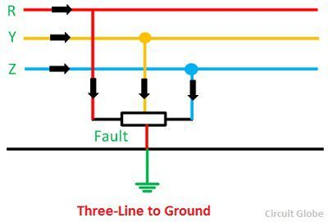

**b.** **L – L – L – G (Three-phase line to the ground fault)** – The three-phase line to ground fault includes all the three phase of the system. The L – L – L – G fault occurs between the three phases and the ground of the system. The probability of occurrence of such type of fault is nearly 2 to 3 percent.

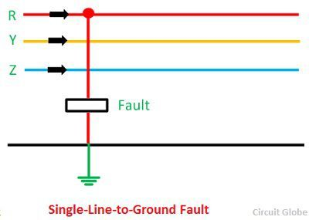

A rough occurrence of symmetrical faults is in the range of 2 to 5% of the total system faults. However, if these faults occur, they cause a very severe damage to the equipment’s even though the system remains in balanced condition.

The analysis of these faults is required for selecting the rupturing capacity of the circuit breakers, choosing set-phase relays and other protective switchgear. These faults are analysed on per phase basis using bus impedance matrix or Thevenins’s theorem.

### 2.2.3.2 Unsymmetrical Faults

The most common faults that occur in the power system network are unsymmetrical faults. This kind of fault gives rise to unsymmetrical fault currents (having different magnitudes with unequal phase displacement). These faults are also called as unbalanced faults as it causes unbalanced currents in the system.

Up to the above discussion, unsymmetrical faults include both open circuit faults (single and two phase open condition) and short circuit faults (excluding L-L-L-G and L-L-L).

The figure below shows the three types of symmetrical faults occurred due to the short circuit conditions, namely phase or line to ground (L-G) fault, phase to phase (L-L) fault and double line to ground (L-L-G) fault.

**1. Single Line-to-Line Ground** – The single line of ground fault occurs when one conductor falls to the ground or contact the neutral conductor. The 70 – 80 percent of the fault in the power system is the single line-to-ground fault.



**2. Line – to – Line Fault** – A line-to-line fault occurs when two conductors are short circuited. The major cause of this type of fault is the heavy wind. The heavy wind swinging the line conductors which may touch together and hence cause short-circuit. The percentage of such type of faults is approximately 15 – 20%.

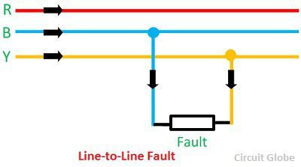

**3. Double Line – to – line Ground Fault** – In double line-to-ground fault, the two lines come in contact with each other along with the ground. The probability of such types of faults is nearly 10 %.

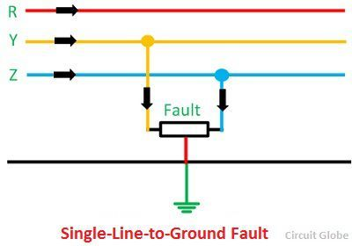

Unsymmetrical faults are analysed using methods of unsymmetrical components in order to determine the voltage and currents in all parts of the system. The analysis of these faults is more difficult compared to symmetrical faults.

This analysis is necessary for determining the size of a circuit breaker for largest short circuit current. The greater current usually occurs for either L-G or L-L fault

# 

# 

# Chapter 3

# Fast Fourier Transform (FFT)

## 3.1 Signals

In the fields of communications, signal processing, and in electrical engineering more generally, a signal is any time‐varying or spatial‐varying quantity

This variable (quantity) changes in time

•Speech or audio signal: A sound amplitude that varies in time

•Temperature readings at different hours of a day

•Stock price changes over days

Signals can be classified by continues‐time signal and discrete‐time signal:

•A discrete signal or discrete‐time signal is a time series, perhaps a signal that has been sampled from a continuous‐time signal

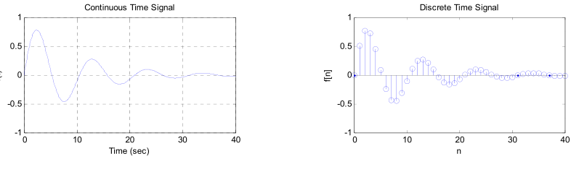•A digital signal is a discrete‐time signal that takes on only a discrete set of Values

## 

## 3.2 Periodic Signal:

Periodic signal and non‐periodic signal:

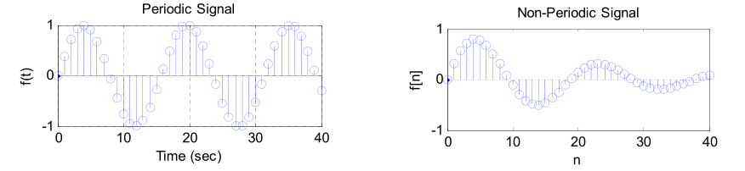

• Period T: The minimum interval on which a signal repeats

• Fundamental frequency: f0=1/T

Fundamental frequency: f0 1/T

• Harmonic frequencies: kf0

• Any periodic signal can be approximated by a sum of many sinusoids at harmonic frequencies of the signal (kf0) with appropriate amplitude and phase.

• Instead of using sinusoid signals, mathematically, we can use the complex exponential functions with both positive and negative harmonic frequencies



Euler formula: …. (1)

## 3.3 Time‐Frequency Analysis:

A signal has one or more frequencies in it, and can be viewed from two different standpoints Time domain and Frequency domain.

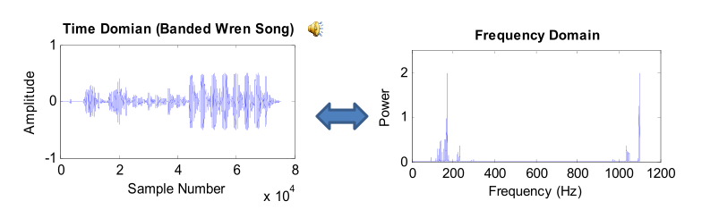Why frequency domain analysis?

•To decompose a complex signal into simpler parts to facilitate analysis

•Differential and difference equations and convolution operations in the time domain become algebraic operations in the frequency domain

•Fast Algorithm (FFT)

## 3.4 Fourier Transform:

We can go between the time domain and the frequency domain by using a tool called Fourier transform

• A Fourier transform converts a signal in the time domain to the frequency domain (spectrum). An inverse Fourier transform converts the frequency domain components back into the original time domain signal

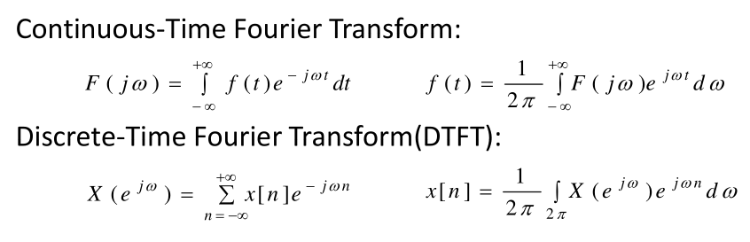

…….(2)

…… (3)

### 3.4.1 Fourier Representation for Four Types of Signals:

The signal with different time‐domain characteristics has different Frequency ‐ domain characteristics

1. Continues‐time periodic signal ‐‐‐> discrete non‐periodic

Spectrum

1. Continues‐time non‐periodic signal ‐‐‐> continues non‐periodic spectrum
2. Discrete non‐periodic signal ‐‐‐> continues periodic spectrum
3. Discrete periodic signal ‐‐‐> discrete periodic spectrum
4. The last transformation between time‐domain and frequency is most useful. The reason that discrete is associated with both time‐domain and frequency domain is because computers can only take finite discrete time signals.

## 3.5 Periodic Sequence:

A periodic sequence with period N is defined as:

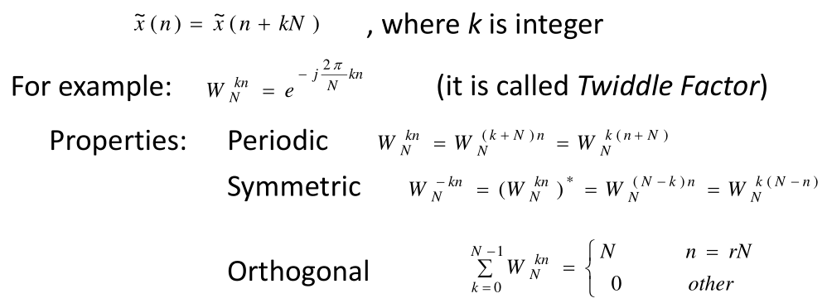

…... (4)

## 3.6 Discrete Fourier series (DFS):

Periodic signals may be expanded into a series of sine and cosine functions

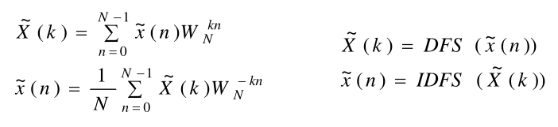

….. (5)

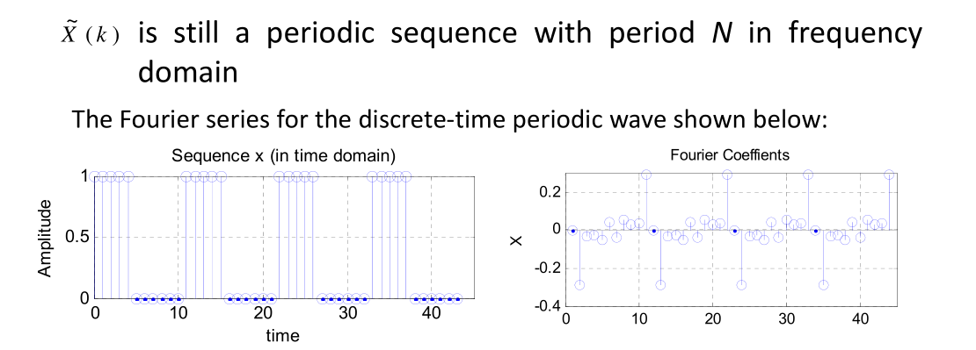

## 

## 3.7 Finite Length Sequence

Real lift signal is generally a finite length sequence

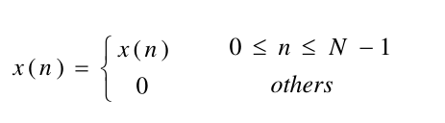

…… (6)

If we periodic extend it by the period N then

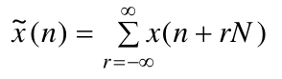

…… (7)

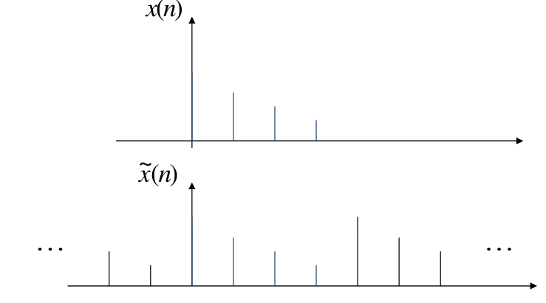

## 

## 3.8 Relationship between Finite Length Sequence and Periodic Sequence

A periodic sequence is the periodic extension of a finite length sequence

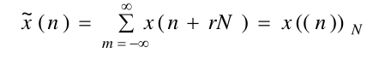

……. (8)

A finite length sequence is the principal value interval of the periodic Sequence

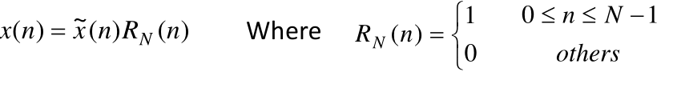

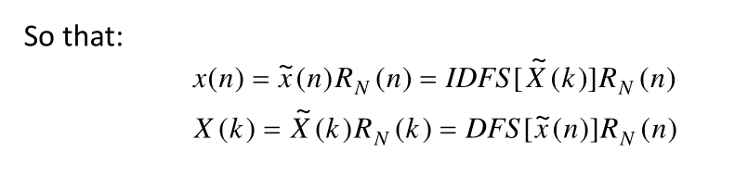

….. (9)

## 3.9 Discrete Fourier Transform (DFT):

• Using the Fourier series representation we have Discrete Fourier Transform (DFT) for finite Length signal

• DFT can convert time‐domain discrete signal into frequency‐ domain discrete spectrum

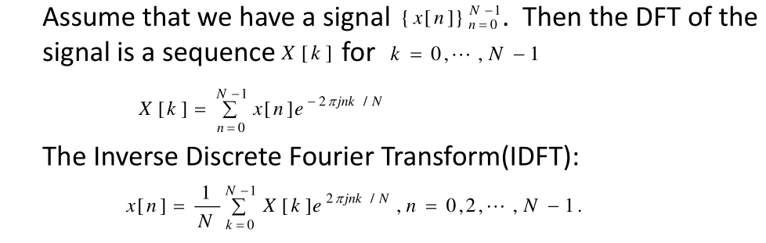

### 3.9.1 DFT Example

The DFT is widely used in the fields of spectral analysis, acoustics medical imaging and

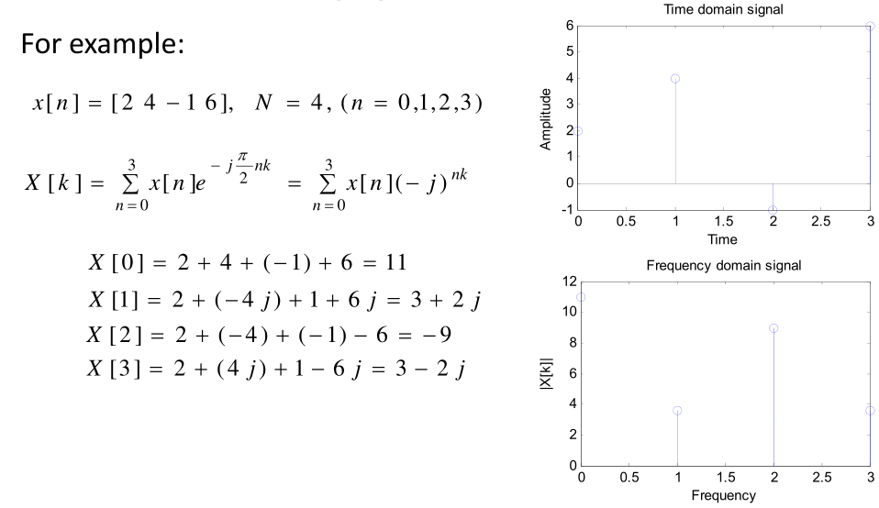Telecommunications

## 

## 3.10Fast Fourier Transform (FFT)

•The Fast Fourier Transform does not refer to a new or different type of Fourier transform. It refers to a very efficient algorithm for computing the DFT

•The time taken to evaluate a DFT on a computer depends principally on the number of Multiplications involved. DFT needs principally on the number of multiplications involved. DFT needs N2 multiplications. FFT only needs Nlog2 (N)

•The central insight which leads to this algorithm is the realization that a discrete Fourier transform of a sequence of N points can be written in terms of two discrete Fourier transforms of length N/2

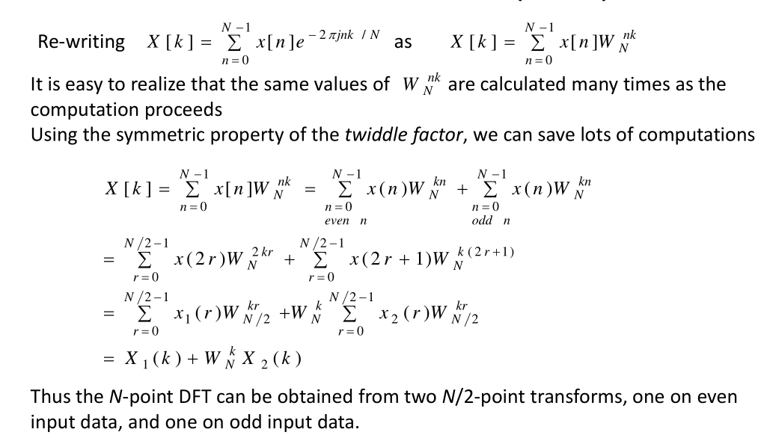•Thus if N is a power of two it is possible to recursively apply this decomposition until we are left with discrete Fourier transforms of sin

# Chapter 4

# Simulation of Low Impedance Faults in a Power System Network

## 4.1 Simulation of Power system network:

The single line diagram of the power system network considered in this study has been simulated in MATLAB and shown in fig 3.1. The specifications of the system shown in fig 3.1 have been provided in table 3.2

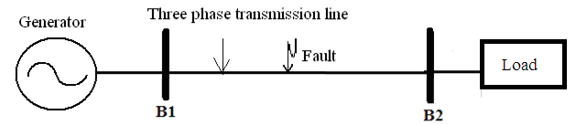

Figure 4. Single Line diagram of 400 kV, 50 Hz, 3-phase power system network.

Sampling time: 78.28 μs .Time period of simulation in MATLAB: 0.06secs.

|  |  |
| --- | --- |
| System Components | Specifications |
| Generator | Impedance = (0.2+j4.49) Ω, X/R ratio = 22.45. |
| Transmission Line | Length: 300 Km , R1 = 0.02336Ω/km,  R2 = 0.02336Ω/km, R0 = 0.38848Ω/km,  L1 = 0.95106mH/km, L2 = 0.95106mH/km,  L0 = 3.25083mH/km, C1 = 12.37nF/km, C2 = 12.37nF/km, C0 = 8.45 nF/km |
| Balanced Load | Load Impedance = (720+j11)Ω, p.f.= 0.9, MVA rating = 200 |

Sampling frequency: 12.8 kHz.

**Table 4.1**: Specifications of the power system network shown in Fig. 3.1

## 

## 4.2. Simulation of Faults:

The following 7 types of faults have been simulated as shown below:

Single line to Ground – AG, BG, CG (e.g. AG Phase A to Ground)

Double line to Ground – ABG, BCG, CAG (e.g. ABG Phase A to Ground and Phase B to Ground)

Triple line to Ground. (ABCG Phase A to Ground, Phase B to Ground and Phase C to Ground)

All the fault simulated in steps of 100 km on the transmission line from the sending end (B1) of the power system. As the objective is to simulate low impedance faults, fault resistance has taken to 5 Ohm.

The fault resistance is 0 ohm but the ground resistance for all the faults has been considered as 5-ohm, 10-ohm, 15-ohm, 20-ohm. The voltage wave forms of all the simulated faults at a particular condition have been shown in Figs. (4.2-4.8).

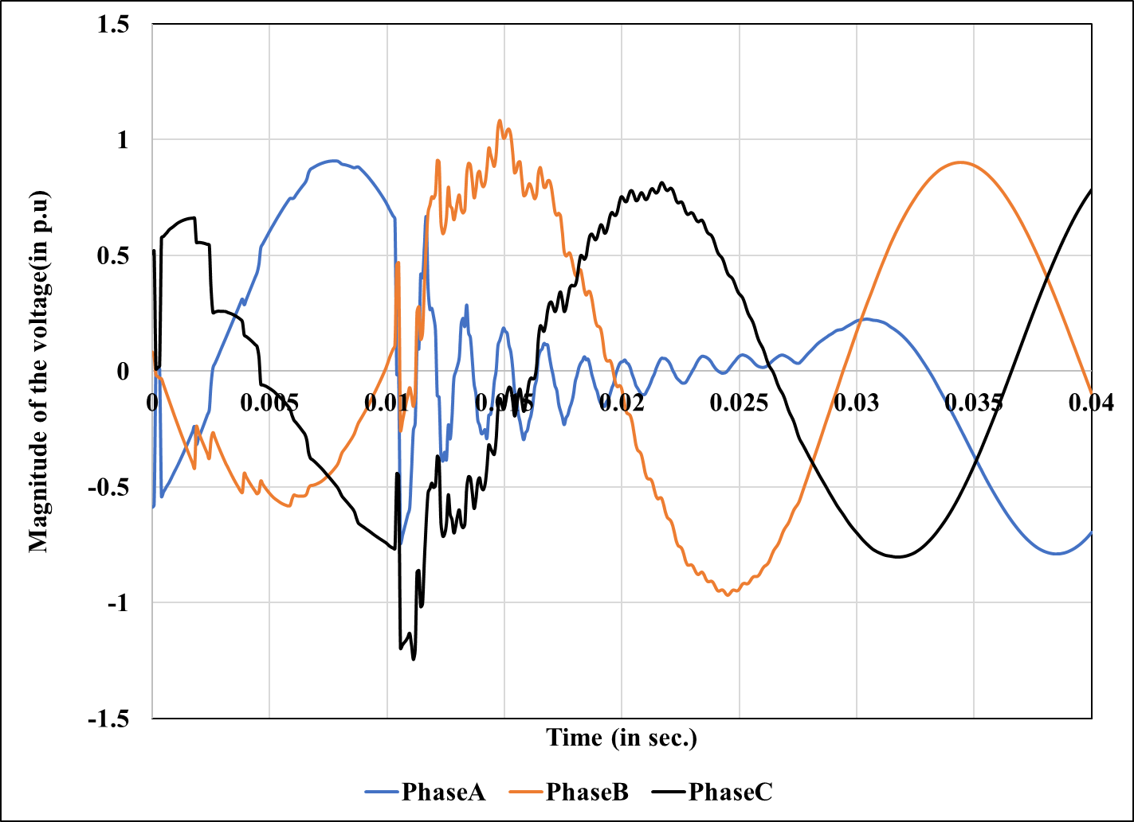

Figure 4.2 3 Phase Voltage Waveform during AG type fault occurring at 100 km from sending end B1 with ground resistance 5 ohm

#### 

Figure 4.4 3 Phase Voltage Waveform during CG type fault occurring at 100 km from sending end B1 with ground resistance 5 ohm

Figure .3 3 Phase Voltage Waveform during BG type fault occurring at 100 km from sending end B1 with ground resistance 5 ohm

#### 

Figure4. 3 Phase Voltage Waveform during ABG type fault occurring at 100 km from sending end B1 with ground resistance 5 ohm

#### 

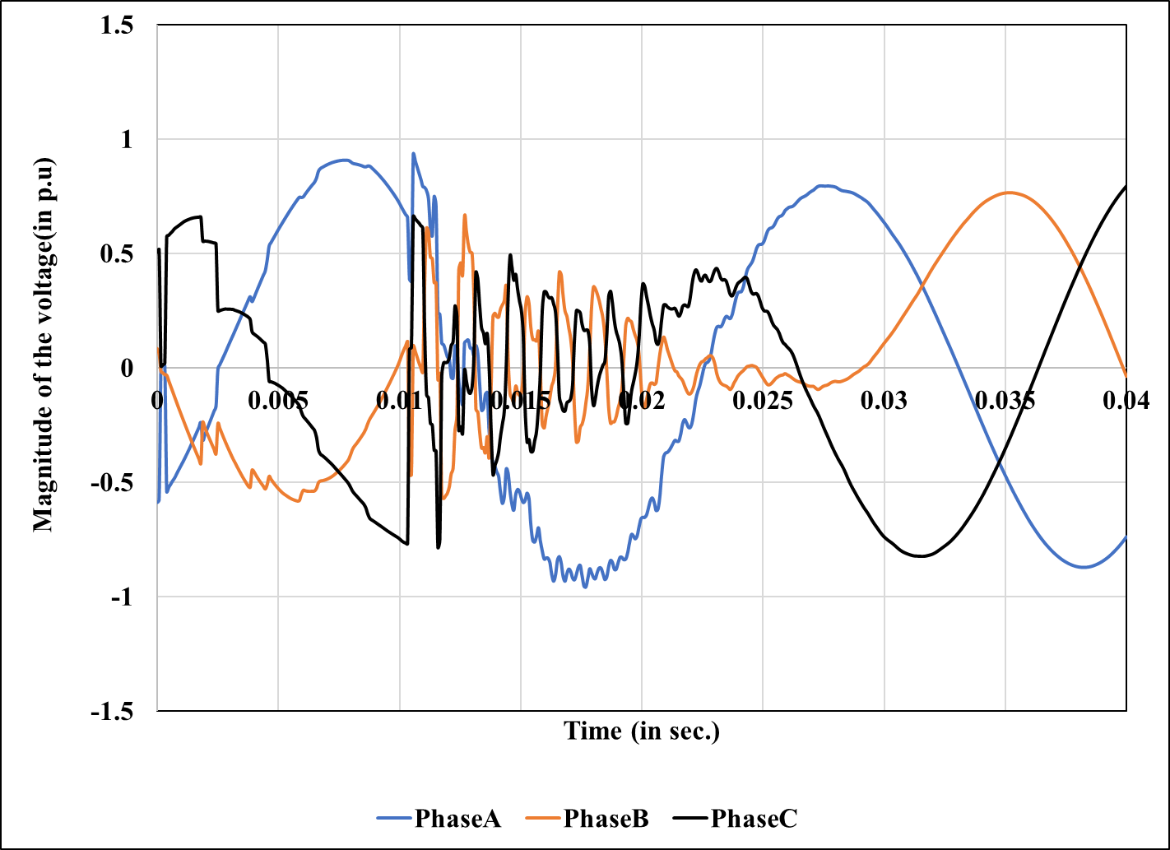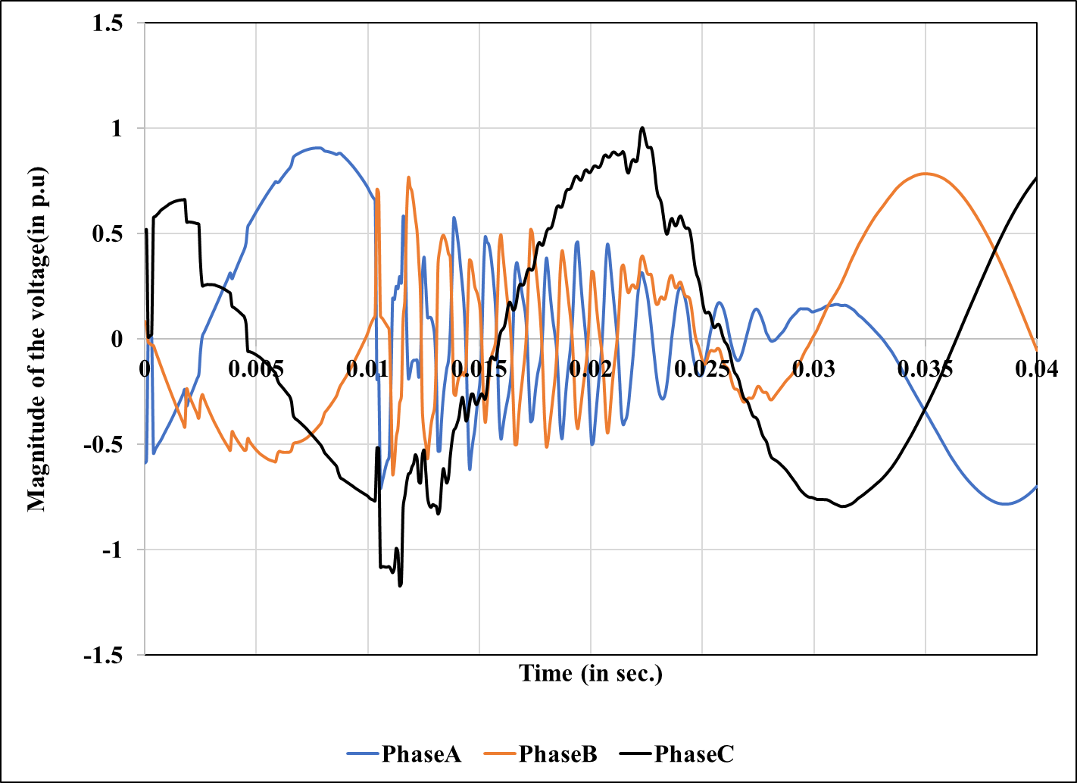

Figure 4. 3 Phase Voltage Waveform during BCG type fault occurring at 100 km from sending end B1 with ground resistance 5 ohm

#### 

Figure 4. 3 Phase Voltage Waveform during CAG type fault occurring at 100 km from sending end B1 with ground resistance 5 ohm

#### 

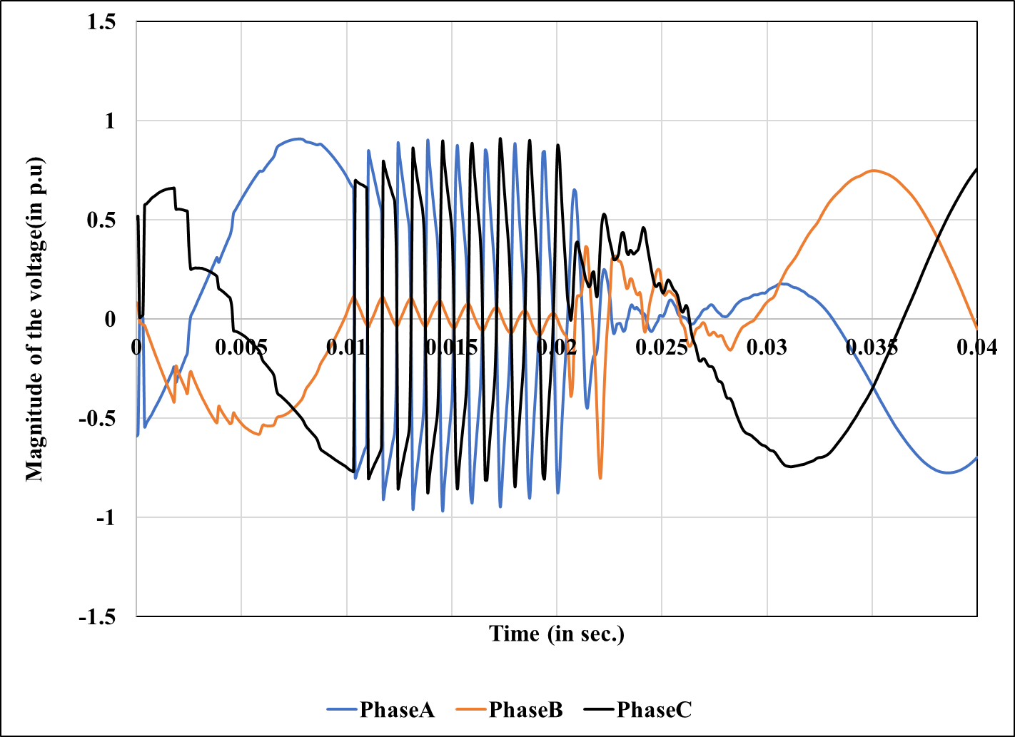

Figure 4. 3 Phase Voltage Waveform during ABCG type fault occurring at 100 km from sending end B1 with ground resistance 5 ohm

# 

# Chapter 5

# Application of FFT (Fast Fourier Transform) in Fault Classification

## 5.1. Method of analysis:

FFT has been implemented on the voltage waveform of each phase simulated at the sending end of the network during different types of fault condition. The output of the FFT is a complex matrix. The absolute value of the FFT matrix is obtained which is referred to as the frequency spectrum of the voltage waveform. The frequency spectrum of voltage during different kinds of fault are shown in Fig [9 to 15].

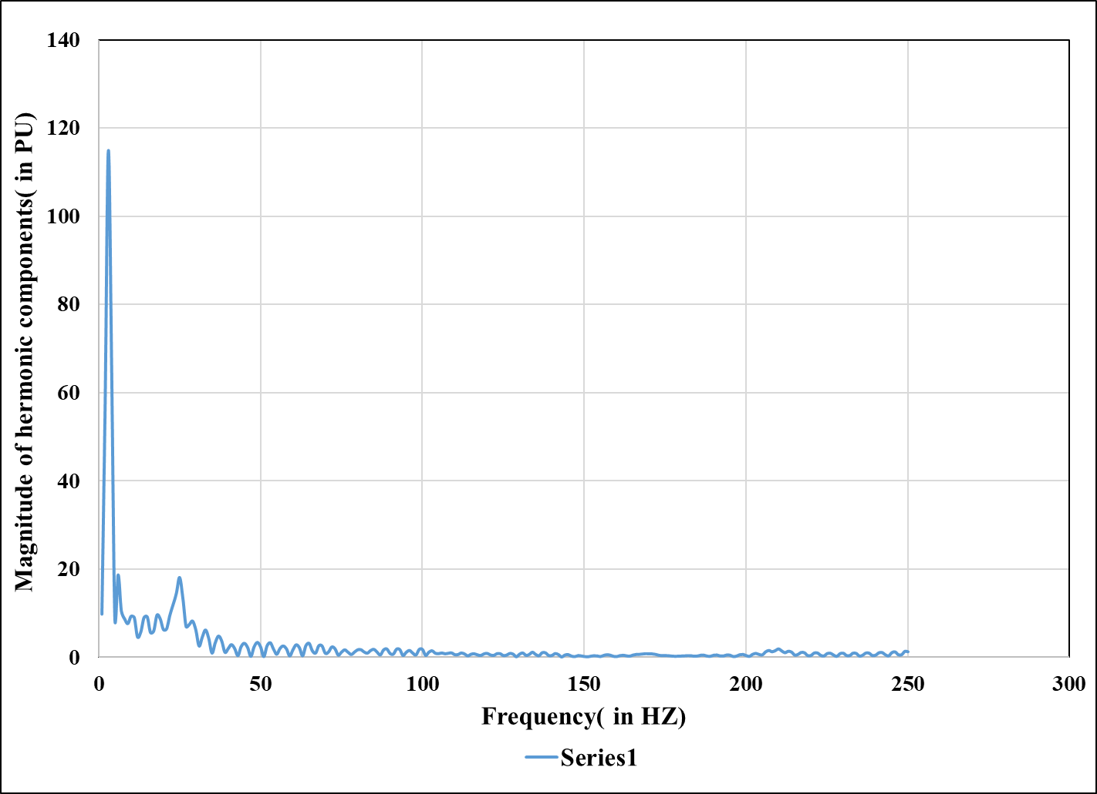The maximum value of every spectrum is noted as an important feature for classification of fault in the present study. The process is respected for all the types of faults at different location of the transmission line

Figure 5.1 Frequency spectrum of the voltage signal of phase A during AG type of fault occurring at 100 km from the sending end of the power system

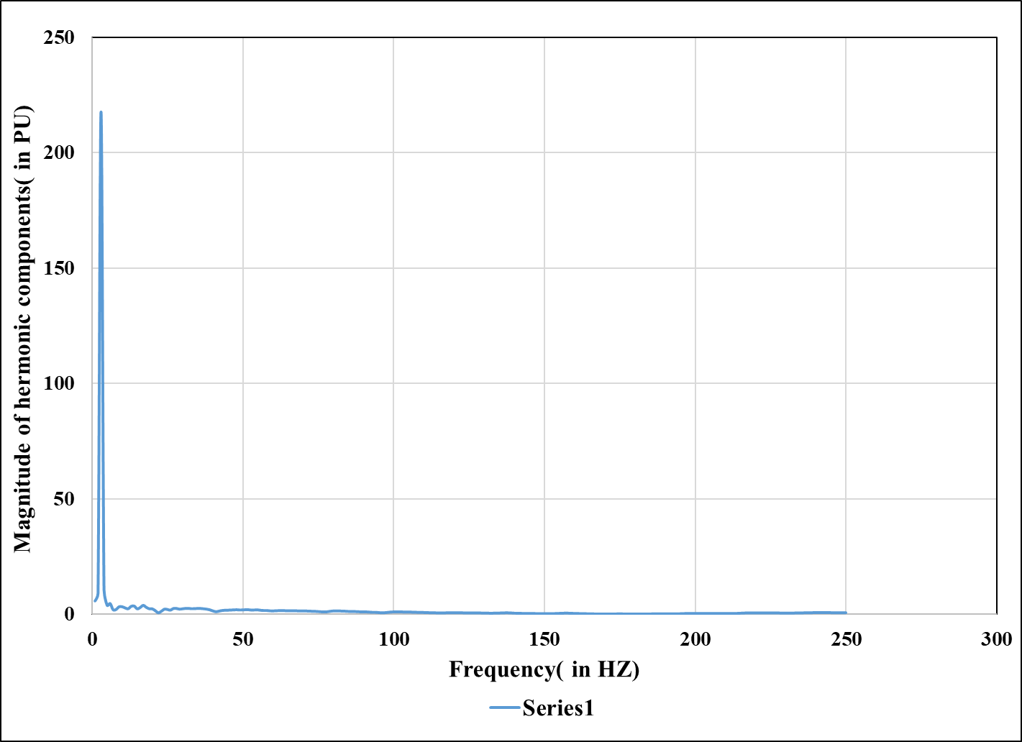

Figure 5.2 Frequency spectrum of the voltage signal of phase B during BG type of fault occurring at 100 km from the sending end of the power system

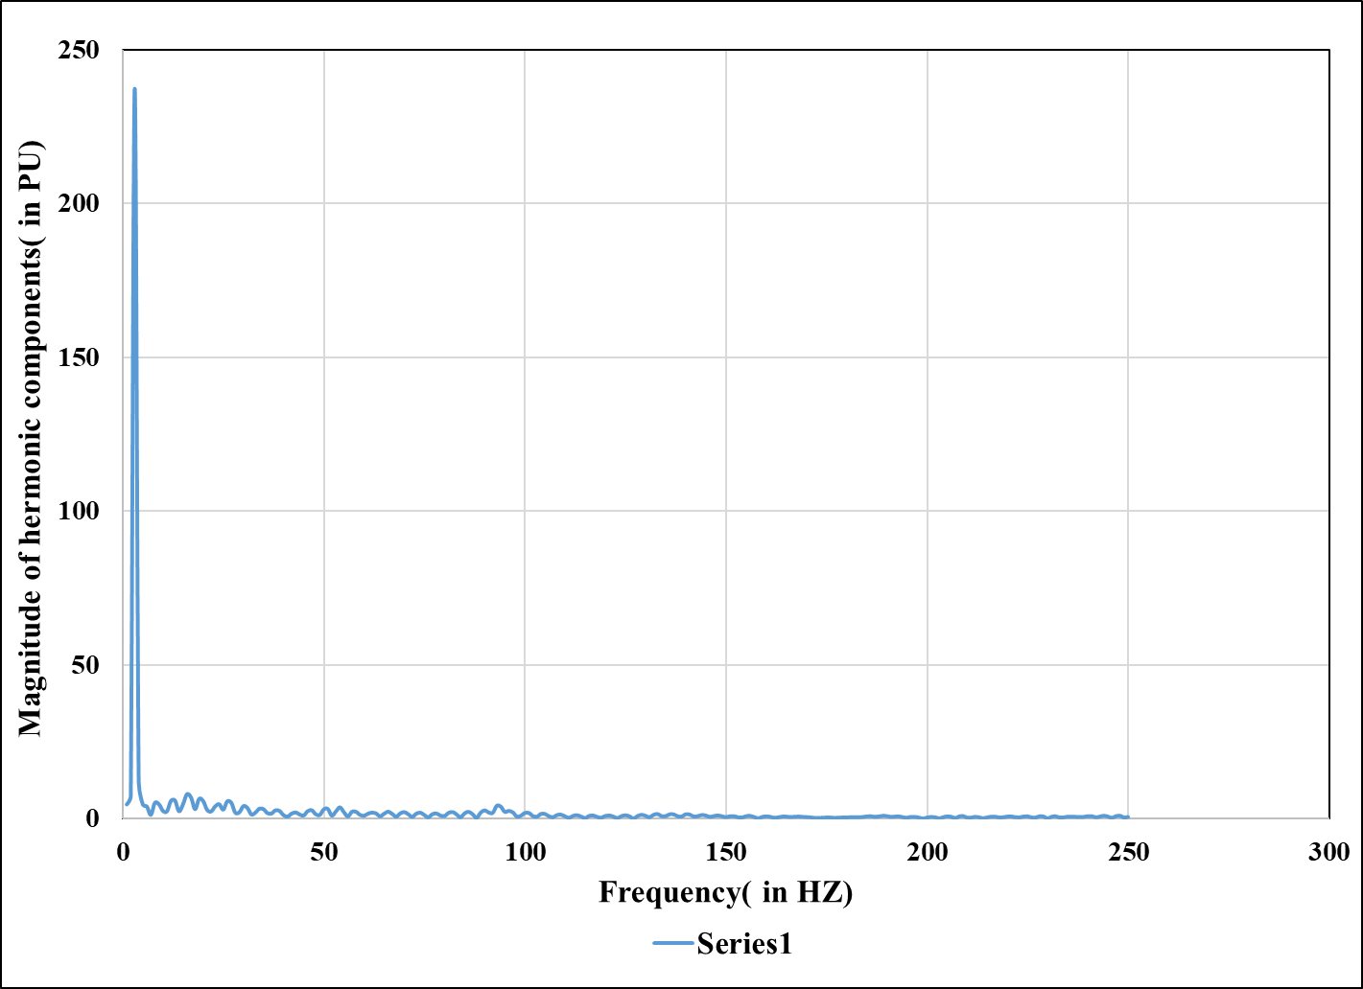

Figure 5.3 Frequency spectrum of the voltage signal of phase C during CG type of fault occurring at 100 km from the sending end of the power system

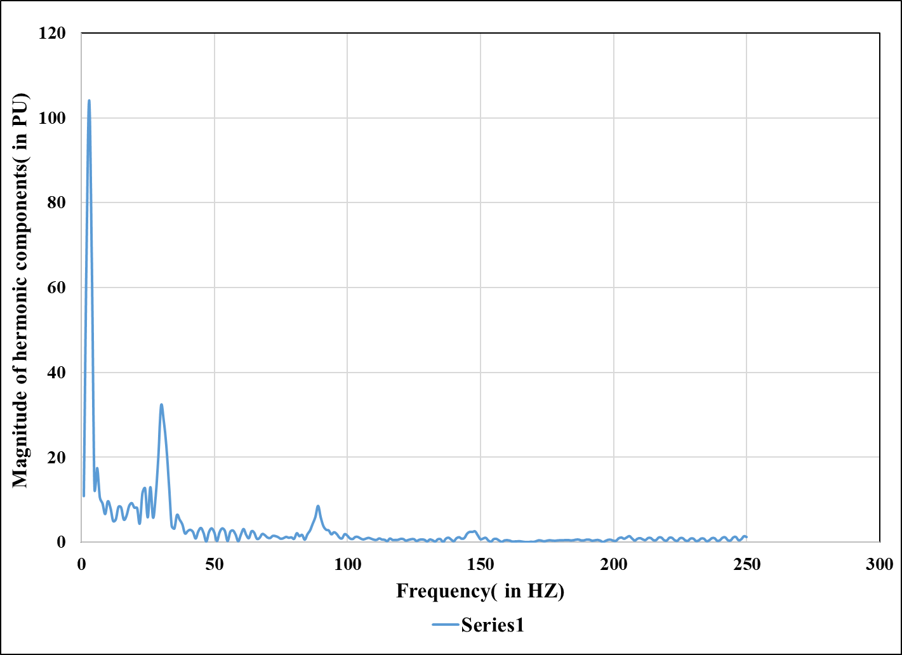

Figure 5.4 Frequency spectrum of the voltage signal of phase A during ABG type of fault occurring at 100 km from the sending end of the power system

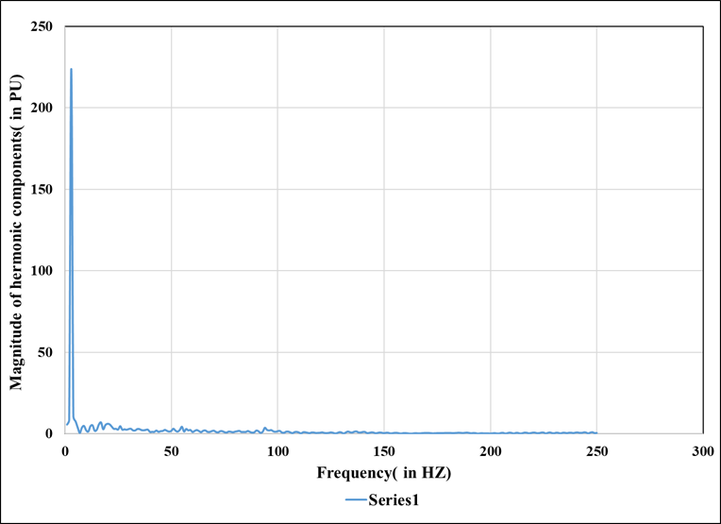

Figure 5.5 Frequency spectrum of the voltage signal of phase B during BCG type of fault occurring at 100 km from the sending end of the power system

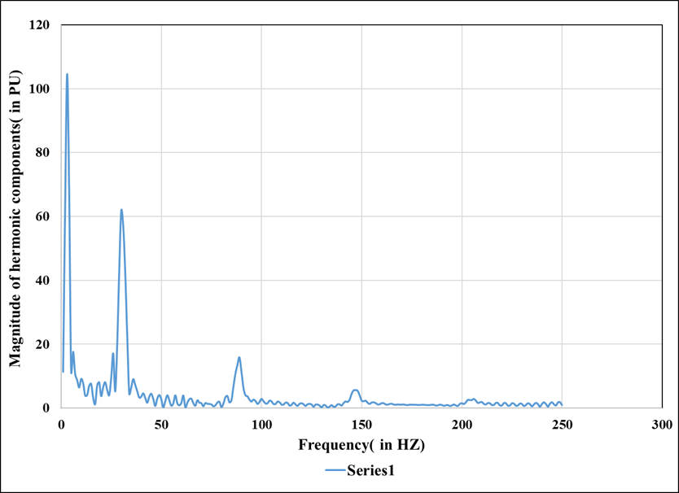

Figure 5.6 Frequency spectrum of the voltage signal of phase C during CAG type of fault occurring at 100 km from the sending end of the power system

# 

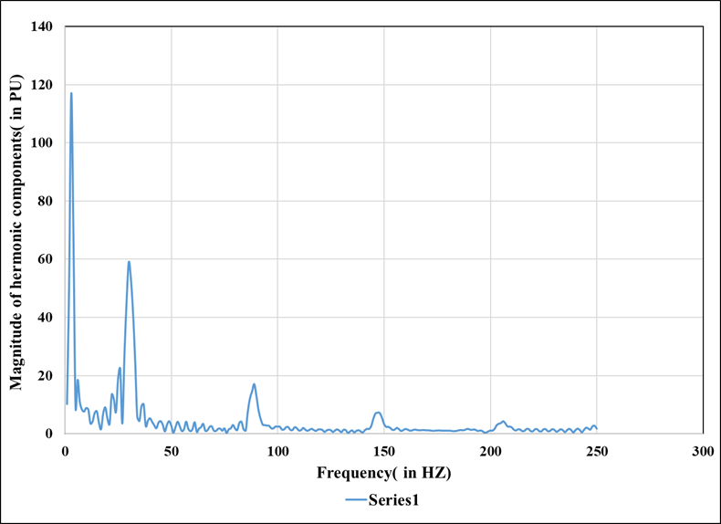

Figure 5.7 Frequency spectrum of the voltage signal of phase A during ABCG type of fault occurring at 100 km from the sending end of the power system

## 5.2. Plot of signal Features:

The feature calculated in section 4.1 for all the types’ faults have been plotted

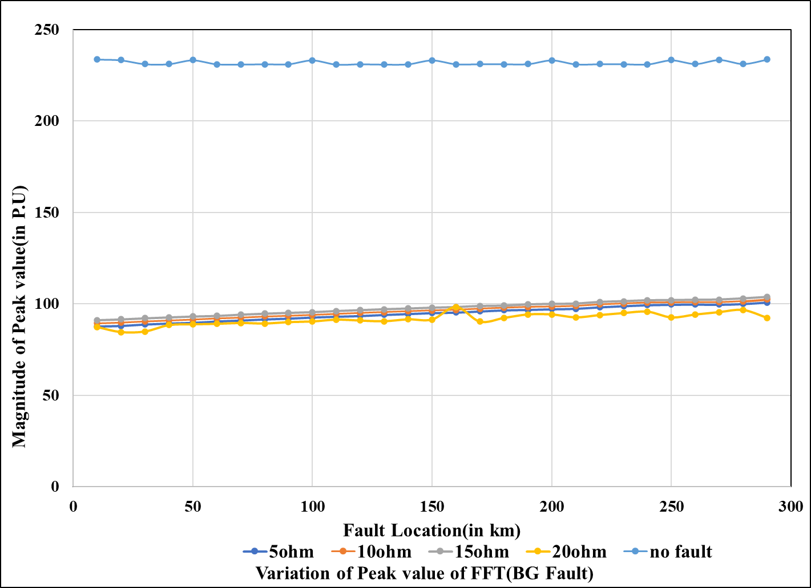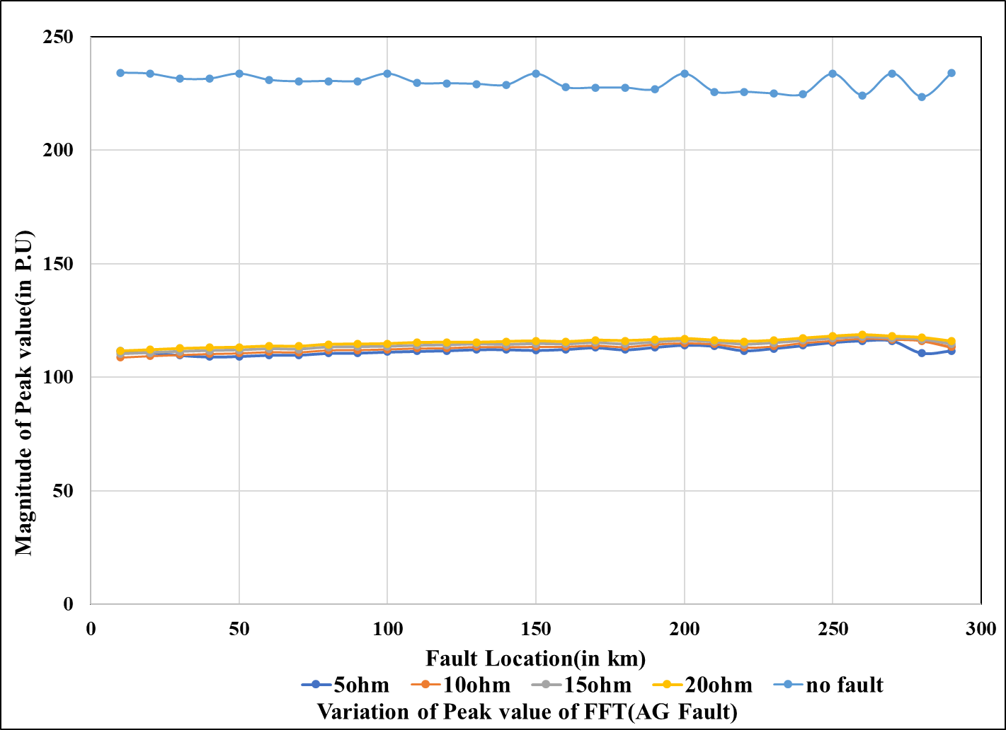In Fig [5.8-5.13] with respect to different fault locations.

Figure 5.9 Plots of magnitudes of features obtained from FFT with respect to fault Location in case of BG fault (phase B)

Figure 5.8 Plots of magnitudes of features obtained from FFT with respect to fault location in case of AG fault (phase A)

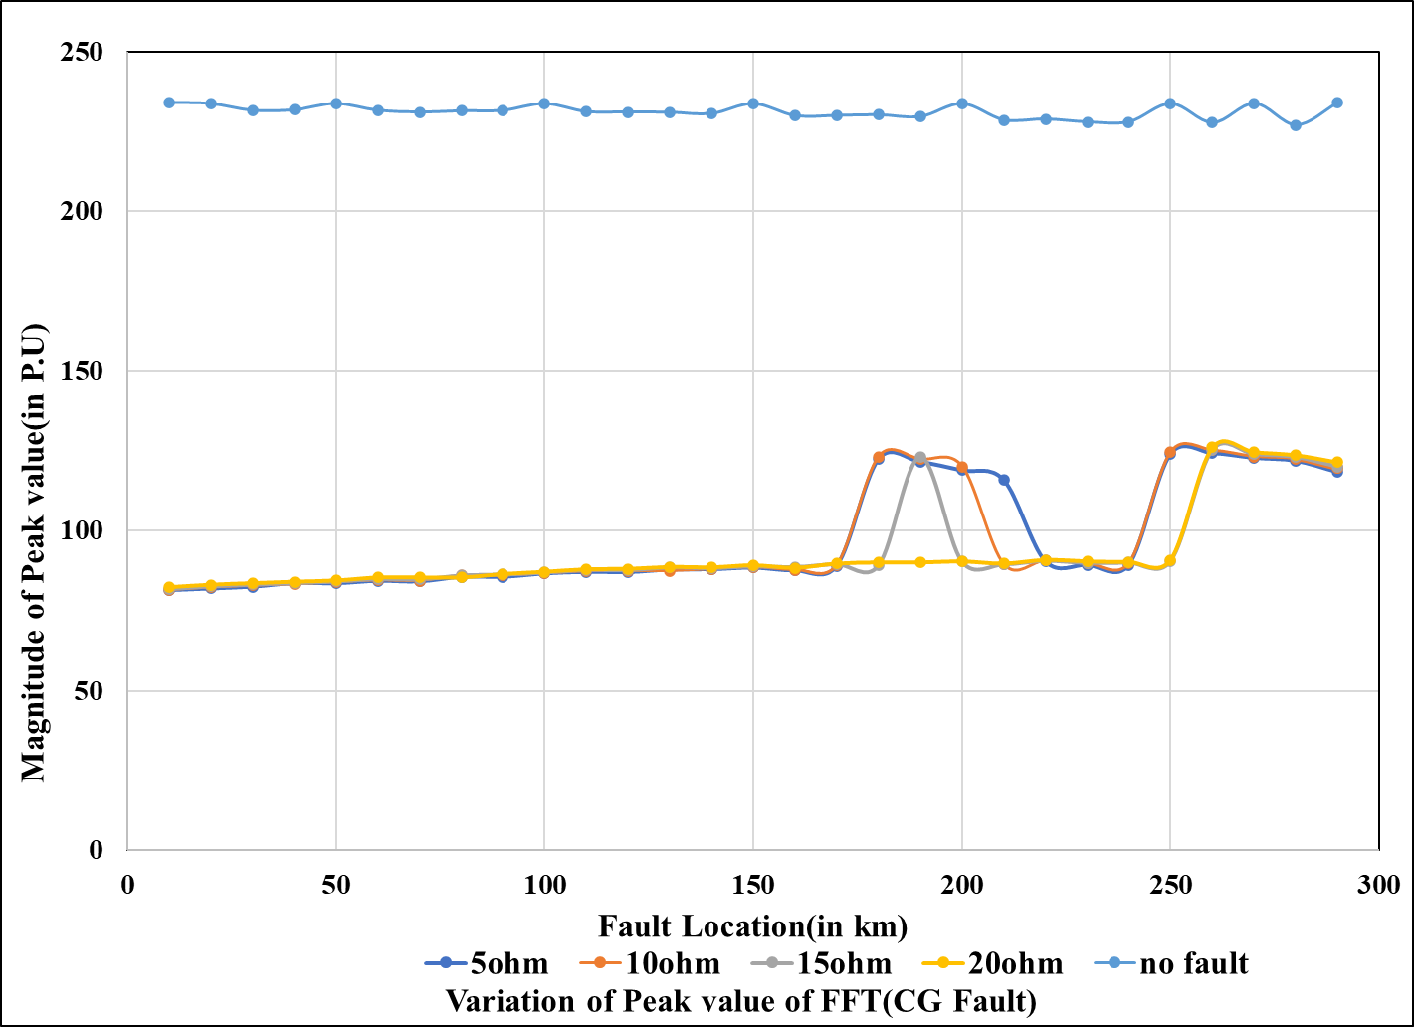

Figure 5.10 Plots of magnitudes of features obtained from FFT with respect to fault location in case of CG fault (phase C)

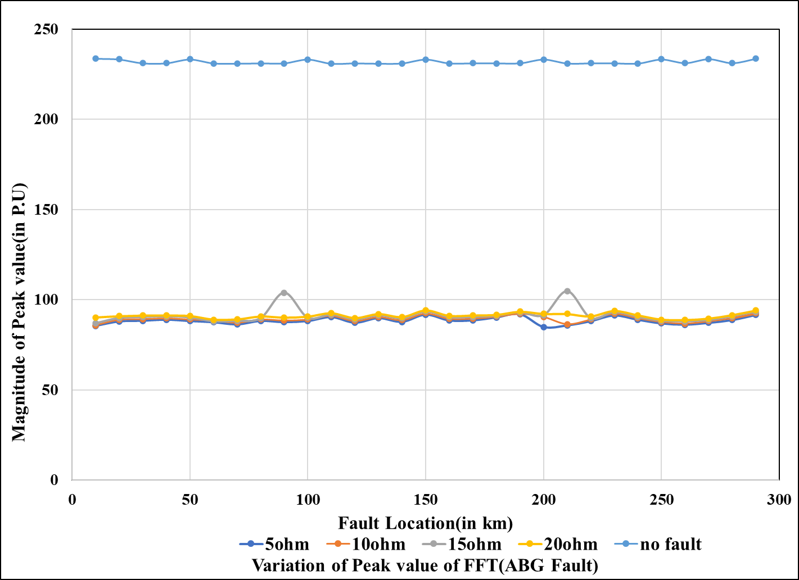

Figure 5.11 Plots of magnitudes of features obtained from FFT with respect to fault location in case of ABG fault (phase B)

#### 

#### 

Figure 5. 13

Figure 5.13 Plots of magnitudes of features often from FFT with respect to fault location in case of ABCG fault (phase A)

Figure 5. 12

Figure 5.12 Plots of magnitudes of features obtained from FFT with respect to fault location in case of BCG fault (phase A)

## 5.3. Plot of signal features of three phases for 5-ohm ground resistance:

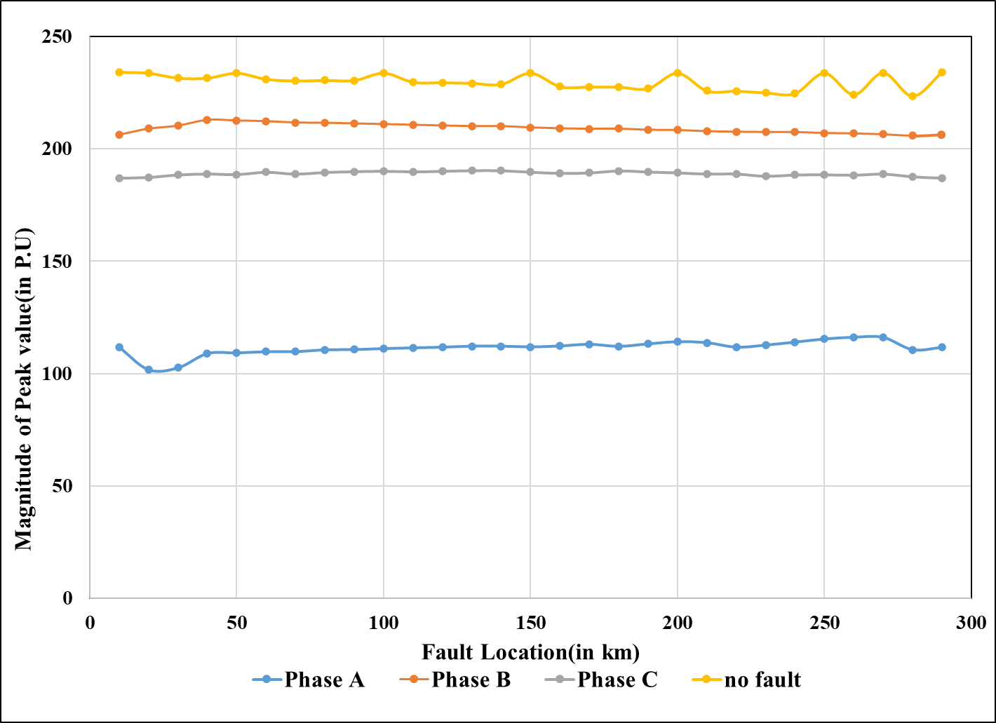

Figure 5.

Figure 5.14 Plots of magnitudes of features obtained from FFT with respect to fault location in case of AG type of fault for the three phases with ground resistance 5 ohm

#### 

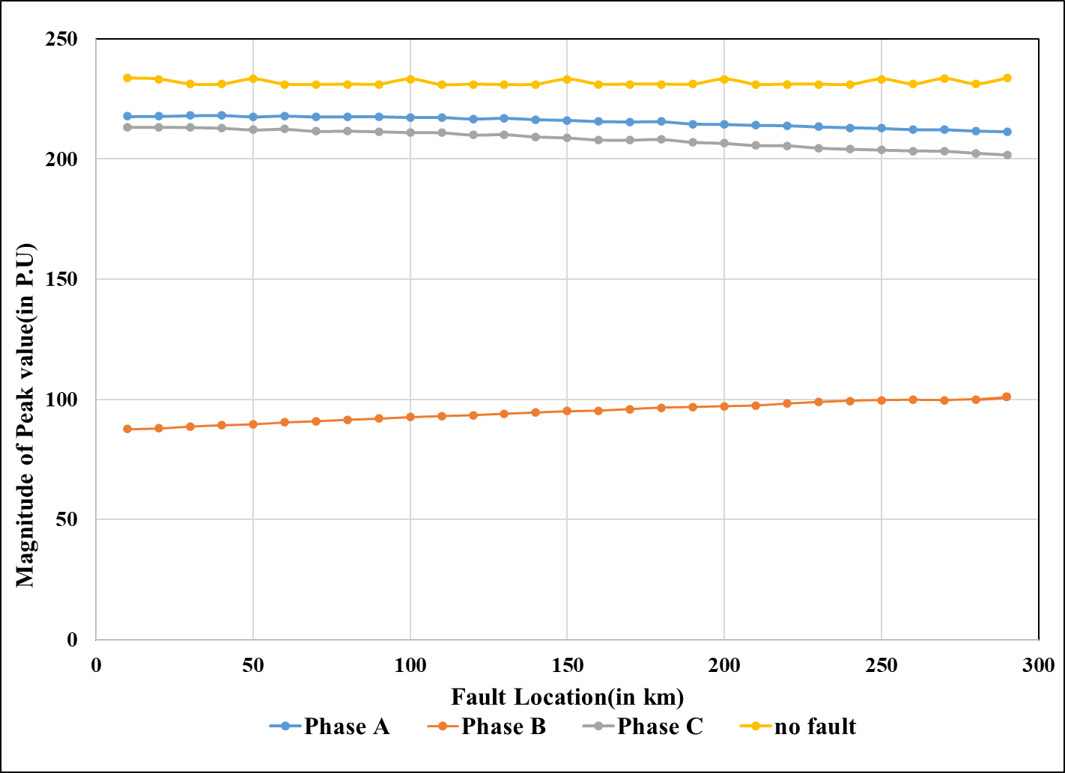

Figure 5.15

Figure 5.15 Plots of magnitudes of features obtained from FFT with respect to fault location in case of BG type of fault for the three phases with ground resistance 5 ohm

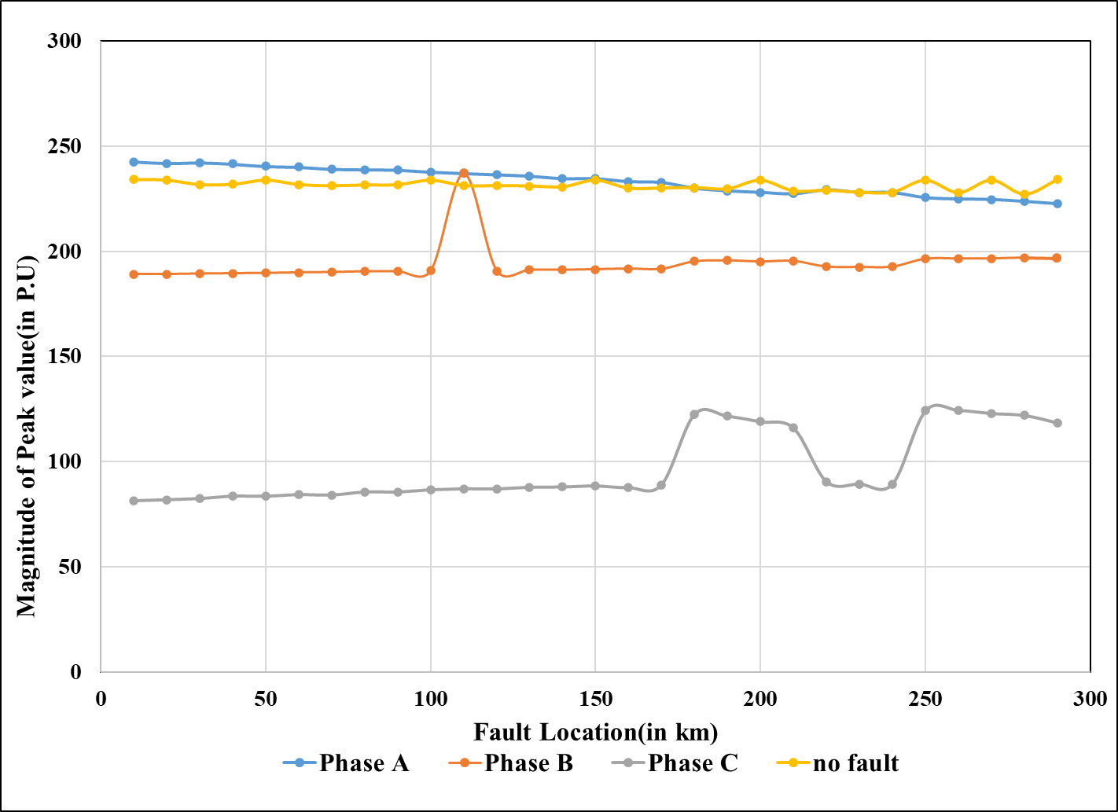

Figure 5. 16

Figure 5.16 Plots of magnitudes of features obtained from FFT with respect to fault location in case of CG type of fault for the three phases with ground resistance 5 ohm

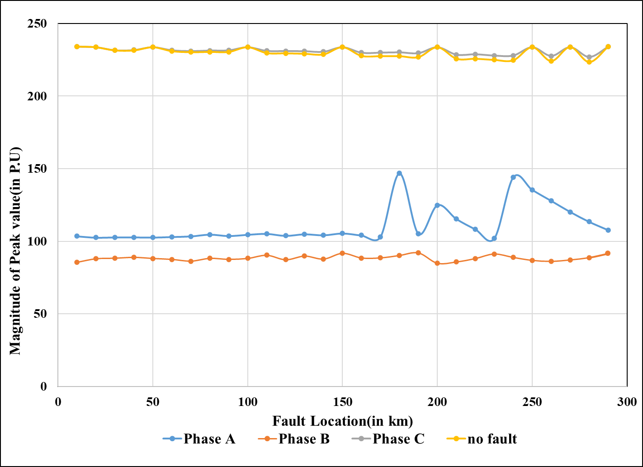

Figure 5. 17

Figure 5.17 Plots of magnitudes of features obtained from FFT with respect to fault location in case of ABG type of fault for the three phases with ground resistance 5 ohm

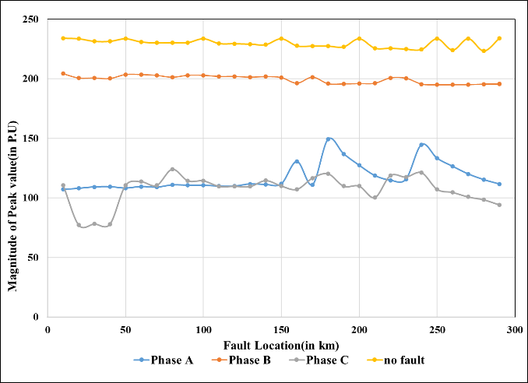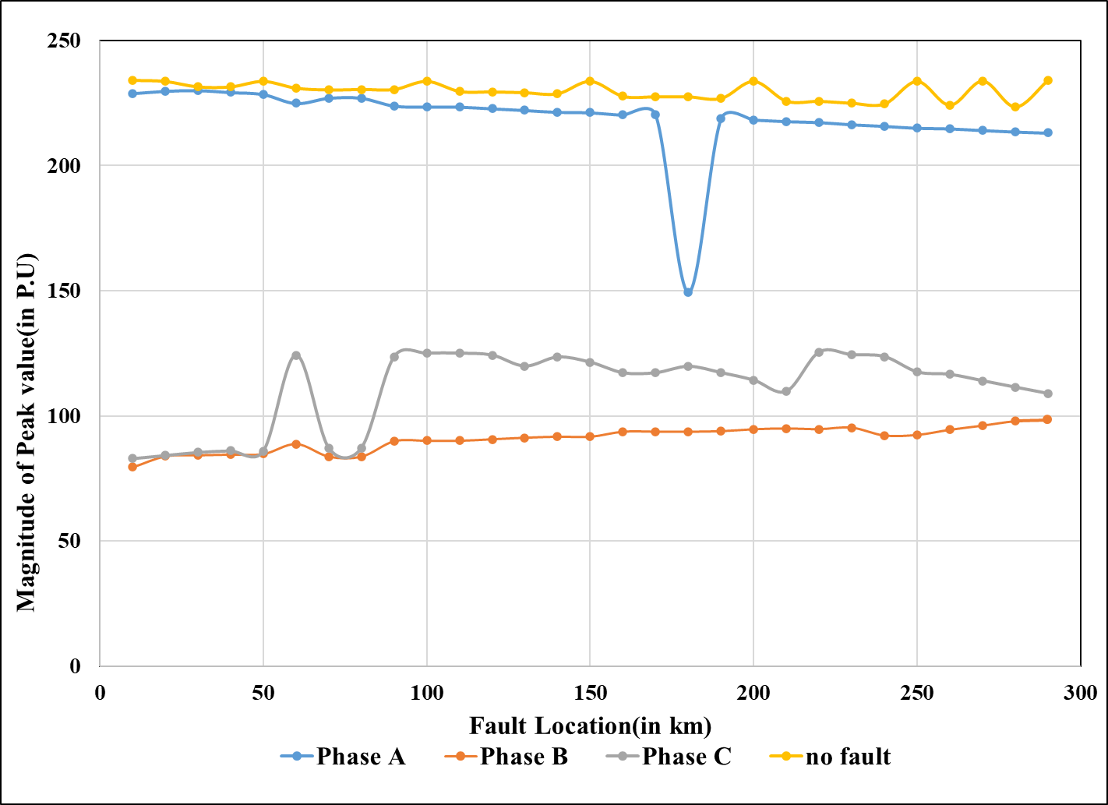

Figure 5. 19

Figure 5.19 Plots of magnitudes of features obtained from FFT with respect to fault location in case of CAG type of fault for the three phases with ground resistance 5 ohm

Figure 5.18

Figure 5.18 Plots of magnitudes of features obtained from FFT with respect to fault location in case of BCG type of fault for the three phases with ground resistance 5 ohm

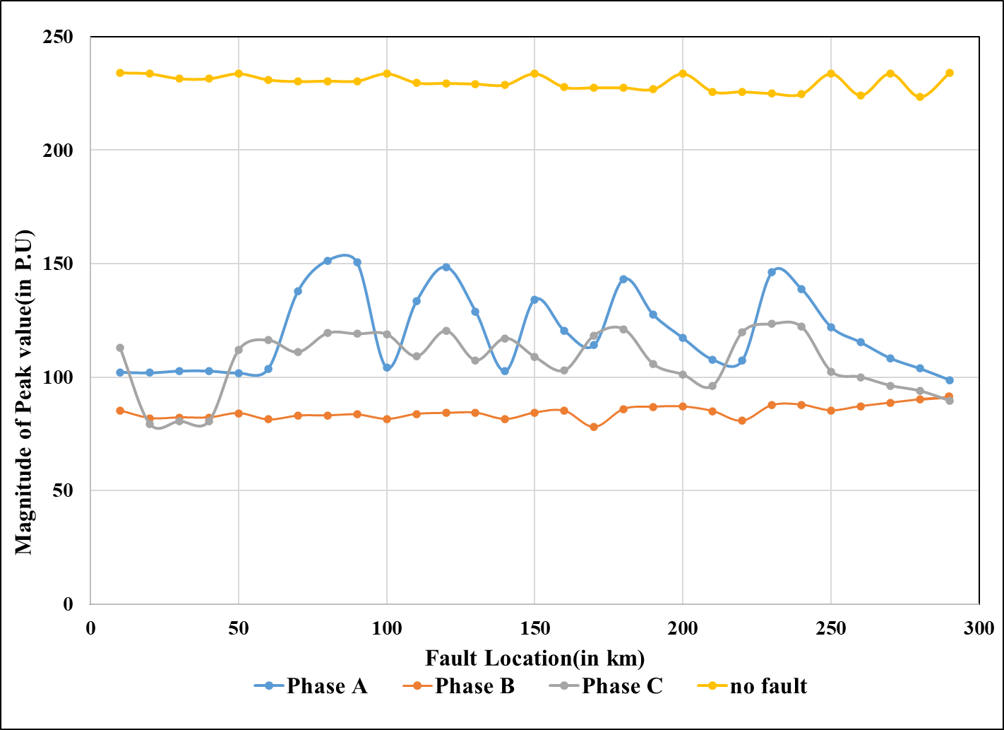

Figure 5. 20

Figure 5.20 Plots of magnitudes of features obtained from FFT with respect to fault location in case of ABCG type of fault for the three phases with ground resistance 5 ohm

## 5.2 Discussion:

The following observation have been made from the plots of the features obtained in Fig [5.14-5.20]

|  |  |  |  |
| --- | --- | --- | --- |
| Name of Faults | Magnitude of Features in comparison to the feature of the voltage Signal during no fault condition. | | |
|  | **Phase A** | **Phase B** | Phase C |
| AG | Lowest | Lower than normal value | Lower than normal value |
| BG | Lower than normal value | Lowest | Lower than normal value |
| CG | Same as normal value | Lower than normal value | Lowest |
| ABG | Lowest | Lowest | Same as normal value |
| BCG | Same as normal value | Lowest | Lowest |
| CAG | Lowest | Lower than normal value | Lowest |
| ABCG | Lowest | Lowest | Lowest |

Table 5.2: Comparison of the magnitude of the features of three phase during different types of fault conditions with those of phases during normal condition.

# 

# Chapter 5

# Conclusion and future scope of work

In the present work, different types of short circuit faults have been simulated with fault resistance 0 ohm and different values of Ground resistances, ranging from 5-ohm, 10-ohm,

15-ohm and 20-ohm respectively. As the ground is involved, hence only L-G, LLG and LLG faults have been simulated. Suitable features have been selected from the voltage signals by using FFT under no fault and different fault conditions. FFT works quite fast as a signal processing tool. The features have been thoroughly studied and it has been observed that the fault conditions can be accurately identified. Also, it was noted that the magnitudes of features remain almost unaffected for different values of ground resistances.

In the future scope of work, the signal features that have been obtained would be used to train a suitable classifier involving neural network or support vector machine so that fault can be notified automatically under different conditions. The effect of noise on the voltage signals also requires to be studied. The study can be further extended applying other signal processing tools like wavelet transform, for obtaining signal features.

# REFERENCE

R. K. K and M. Madakyaru, "Improved fault detection using Dynamic Independent Component Analysis (DICA): An application to multi-variate system," *2019 IEEE International Conference on Distributed Computing, VLSI, Electrical Circuits and Robotics (DISCOVER)*, Manipal, India, 2019, pp. 1-6, doi: 10.1109/DISCOVER47552.2019.9008090.

J. E. Garcia-Bracamonte, J. M. Ramirez-Cortes, J. de Jesus Rangel-Magdaleno, P. Gomez-Gil, H. Peregrina-Barreto and V. Alarcon-Aquino, "An Approach on MCSA-Based Fault Detection Using Independent Component Analysis and Neural Networks," in *IEEE Transactions on Instrumentation and Measurement*, vol. 68, no. 5, pp. 1353-1361, May 2019, doi: 10.1109/TIM.2019.2900143.

J. E. Garcia-Bracamonte, J. Rangel-Magdaleno, J. M. Ramirez-Cortes, P. Gomez-Gil and H. Peregrina-Barreto, "Induction motors fault detection using independent component analysis on phase current signals," *2018 IEEE International Instrumentation and Measurement Technology Conference (I2MTC)*, Houston, TX,

2018, pp. 1-6, doi: 10.1109/I2MTC.2018.8409827.

D. Wei, X. Li, C. Lei and W. Wang, "Process monitoring using independent component analysis based on gradient and newton iteration methods," *2017 Chinese Automation Congress (CAC)*, Jinan, 2017, pp. 3182-3187, doi: 10.1109/CAC.2017.8243324.

Almeida, A.R. & Almeida, O.M. & Santos, Bartolomeu & Barreto, Luiz Henrique & Barros Filho, Allan Kardec. (2017). ICA feature extraction for the location and classification of faults in high-voltage transmission lines. Electric Power Systems Research. 148. 254-263. 10.1016/j.epsr.2017.03.030.

H. C. Dubeya, S. R. Mohanty, N. Kishor and P. K. Ray, "Fault detection in a series compensated transmission line using discrete wavelet transform and independent component analysis: A comparative study," *2011 5th International Power Engineering and Optimization Conference*, Shah Alam, Selangor, 2011, pp. 22-26, doi: 10.1109/PEOCO.2011.5970418.

D. Arifianto, "Source separation using independent component analysis techniques for machine fault detection in the presence of background noise," *2011 2nd International Conference on Instrumentation Control and Automation*, Bandung, 2011, pp. 274-278, doi: 10.1109/ICA.2011.6130171.

P. Wang, J. Xin, X. Gao and Y. Zhang, "Chiller gradual fault detection based on Independent Component Analysis," *The 27th Chinese Control and Decision Conference (2015 CCDC)*, Qingdao, 2015, pp. 2422-2426, doi: 10.1109/CCDC.2015.7162327.

H. C. Dubey, S. R. Mohanty and N. Kishore, "Abrupt change detection of fault in power system using independent component analysis," *2011 International Conference on Signal Processing, Communication, Computing and Networking Technologies*, Thuckafay, 2011, pp. 659-664, doi: 10.1109/ICSCCN.2011.6024633.

J. Lee, B. Kang, K. Shin and S. Kang, "Online process monitoring scheme for fault detection based on Independent Component Analysis (ICA) and Local Outlier Factor (LOF)," *The 40th International Conference on Computers & Industrial Engineering*, Awaji, 2010, pp. 1-6, doi: 10.1109/ICCIE.2010.5668311.

I. Guney, E. Kilic, O. Ozgonenel, M. Ulutas and E. Karadeniz, "Fault detection in induction motors with independent component analysis (ICA)," *2009 IEEE Bucharest PowerTech*, Bucharest, 2009, pp. 1-4, doi: 10.1109/PTC.2009.5282251.

Yinghua Wu, Yinghua Yang, Shukai Qin and Xiaobo Chen, "Process Monitoring and Fault Detection Method Based On Independent Component Analysis," *2006 6th World Congress on Intelligent Control and Automation*, Dalian, 2006, pp. 5586-5589, doi: 10.1109/WCICA.2006.1714143.